ATTENDANCE FOR COURSE COMPLETION
2013-2014
Number of days enrolled in course:
Number of days present:
Attendance (must be 90% or above to acquire immediate credit)
Number of make-up days (if less than 90% attendance)
Student Name: ________________________ | ID#: ______________________ | Date Submitted:_________________
Teacher: _____________________________ | Period: ____________________ | Course Name: __________________
Date Course Started: ___________________ | Date Completed: ____________ | Final Grade: ____________________

Make-Up Dates
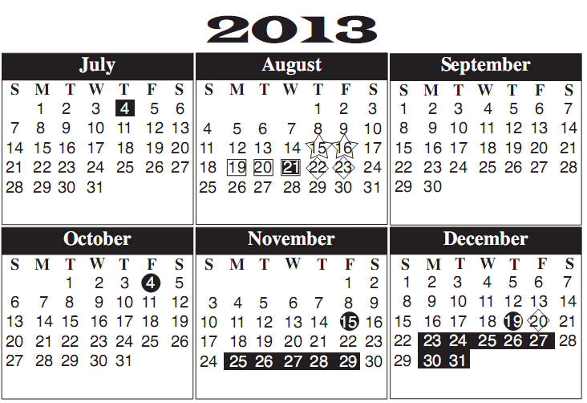
Instructions to follow when filling out, or highlighting the calendar below: (please do not highlight any day/days absent in yellow if they were considered MEDICALS). CODING: Green = 1st day in Class Yellow = day absent Red = last day in class
