Brownsville Independent School District
Lincoln Park Alternative High School
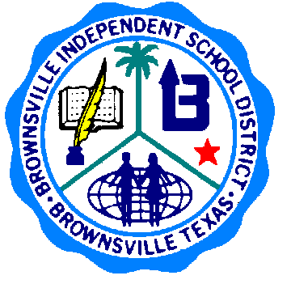
NO CREDIT RECOVERY DOCUMENTATION
2014-2015

Faculty Member: _______________________________ Date: _____________________

Activity: _______________________________________ Course: ____________________#__________ or NA
Sign In Sheet
Student Name (Print) Student Signature Student ID Hours Awarded

Submit to: Mrs. Renteria*******

